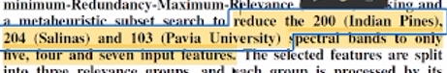
task 1: just write to reduce the spectral band. Because our target is to generalize for every dataset. Then we have to write that these 3 datasets are applied to our method.
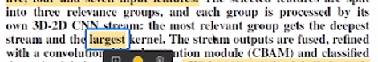
Task 2: is there any way to write anything instead of largest. And need to capitalized every module name we used in our methodology. For example convolutional block attention module -> Convolutional Block Attention Module.
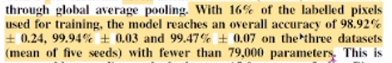
Task 3: here we should mention 3 datasets in short form. Without giving (mean of five seeds) inside bracket, how are we going to write in sentence we need to investigate. Mainly we do not need to mention in bracket. This need to explain small 1 line explanation, because reviewer will think that we did cross validation.
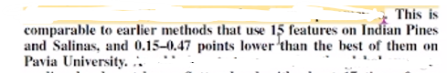
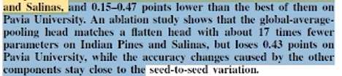
Task 4: we need to use short form of the dataset and and point do not have to mention. Just need to say outperform the investigate methods. Mainly in this here, avoid to use numeric values here. Just use reduced, loses increases etc.

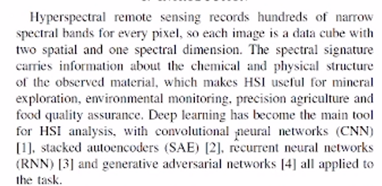
Task 5: We need to check plagiarism and remove plagiarism and already mention that need capitalized every module. And excessive sentence in bracket must be avoid.

